INSURANCE PREMIUM PREDICTION

WIREFRAME DOCUMENT

Shridatta Patil

Homepage

Homepage consists of single page having different section to go on. The page designed to estimate Insurance Premium price prediction and train insurance premium model.

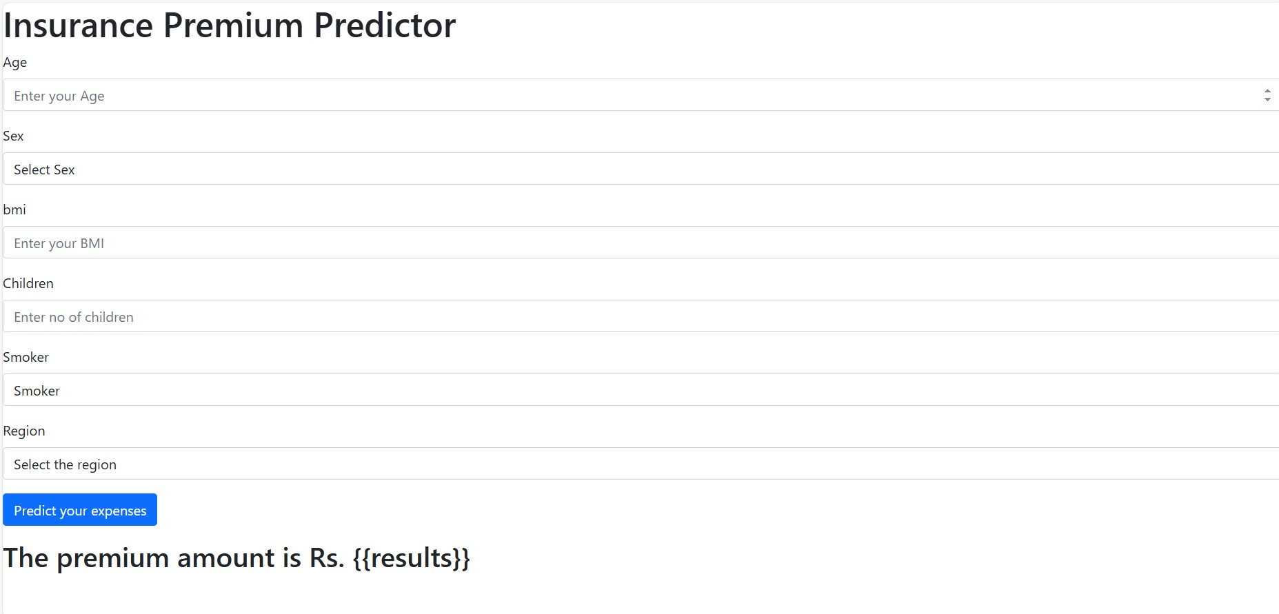

Fill the form for prediction and submit it for prediction.